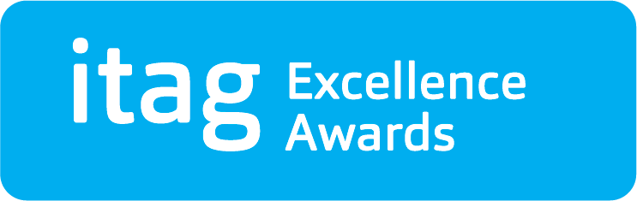 | Award Category  Emerging Technology Start-up Award

Nominee Details
First Name
Surname
Company
Job Title

Nominated By
First Name
Surname
Company
Job Title
Email
Phone No

Criteria for this Award
This itag Excellence Award is conferred on a company/technology start-up within three years of its foundation. This award recognises excellence in early entrepreneurship, product and strategy development, and early market/market position development.
Nominations should make specific reference to the following judging criteria:
- Evidence of market growth over the last (up to) 3 years.
- Evidence of innovation in product / service development over the last (up to) 3 years.
- Evidence of impact through e.g. validated sales / customer / revenue figures and / or industry recognition (prizes, awards, reviews etc.....).
- Evidence of future potential underpinned by e.g. external analysis (industry predictions for instance, rather than just own sales projections).

Background Information
Please provide background details of significant achievements, contributions or performances that qualify the nominee for consideration, according to the criteria for this award. (Max 750 words).
The panel of judges place a strong emphasis on the detail provided herein. As such, the detail provided should be accurate, verifiable, specific and concise.

> Add text here…

Summary Information
Please provide a short summary of the above information. (Max 110 words). This text will be used in a booklet for the Awards Ceremony. This paragraph must be in text format (no bullet points).
Please be aware that this information will be reproduced exactly as provided.

> Add text here…

Terms & Conditions
- itag is a non-profit technology association, our mission to develop and support technology innovation along the AtlanTec Gateway.
- All nominations are evaluated by a judging panel.
- Judge’s decision is final.
- The summary nomination provided on this form will be the basis for PR purposes and may appear on the itag website - www.itag.ie
- I confirm that the details given in this nomination form are correct. I agree to itag making enquiries concerning this nomination.

